|  |  |
| --- | --- |
|  | **MINISTRY OF EDUCATION AND TRAINING** |

**FPT UNIVERSITY**

|  |  |
| --- | --- |
| Capstone Project Document | |
| **Face Detection For Delivery Payment** | |
| **Group 5 - IS** | |
| **Group members** | Nguyễn Văn Hiếu – SE61961 (Leader)  Đinh Phú Thắng – SE62528  Trần Trọng Nghĩa – SE62278  Nguyễn Hữu Lâm– SE61234 |

– **Ho Chi Minh City, 20 January 2019** –

# **D. Report No. 4 Software Design Description**

# **1. Design Overview**

# **SystemArchitecture 2. System Architectural Design**

Figure System Architectural Design

## **2.1 Web application architecture description**

* In web application, the system is developed under MVC architecture style. We choose this architecture for Web application because of following advantages:
  + - Business code is separated with View and Controller that make easy to maintain and easy to understand.
    - Model is used to get and update data from database.
    - Controller takes request from web browser and makes a call to business logic layer.

**2.2 Mobile application architecture description**

* The activity in Mobile client act like a controller to redirect command from view in mobile.
* It takes HTTP Response from server and makes call HTTP Request.

# **3. Component Diagram**

Figure: Component Diagram

|  |  |
| --- | --- |
| **Component Dictionary: Describe component** | |
| **Component Name** | **Description** |
| Mobile Application | Mobile Application package. |
| Web Application | Web Application package: controller, view. |
| Restful Service | Provide API for Mobile Application. |
| Business Logic | Handle business operation for each component. |
| Model Component | Mapping data from database. |
| User Component | Component to handle User activities in the system. |
| Manager Component | Component to handle Manager activities in the system. |
| Customer Component | Component to handle Customer activities in the system. |
| Shipper Component | Component to handle Shipper activities in the system. |
| PayPal Component | Component to handle PayPal activities in the system. |

Table Component Dictionary

# **4. Detail Description**

## **4.1 Class Diagram**

Figure Class Diagram

|  |  |
| --- | --- |
| **Class Dictionary** | |
| **Class Name** | **Description** |
| Payment Type | Abstract class that contains Payment type information. |
| Payment Information | Contain Payment Information |
| Price List | Contain Price List information |
| Role | Contain Role information |
| Account | Contain Account information |
| Shipper | Contain Shipper information |
| Status | Contain Status information |
| Order | Contain Order information |
| Resource | Contain Resource information |
| Order Detail | Contain Order Detail information |
| Town | Contain Town information |
| Store | Contain Store information |
| Product | Contain Product information |
| City | Contain City information |

Table Class Dictionary

## **4.2 Class Diagram Explanation**

### **4.2.1 Payment Type**

**Attribute**

|  |  |  |  |
| --- | --- | --- | --- |
| Attribute | Type | Visibility | Description |
| id | integer | public | Unique identifier of a payment type. |
| type | String | public | Type of Payment |
| name | String | public | Name of payment’s type. |
| description | String | public | Description of payment’s type. |

Table Payment Type Attribute

**Method**

|  |  |  |  |
| --- | --- | --- | --- |
| Method | Return type | Visibility | Description |
| getter() | string | public | get attribute value |
| setter() | void | public | return value of attribute |

Table Payment Type Method

### **4.2.2 Payment Information**

**Attribute**

|  |  |  |  |
| --- | --- | --- | --- |
| Attribute | Type | Visibility | Description |
| id | integer | public | Unique identifier of a payment information. |
| Fr_Account_id | integer | public | Linked to table of account |
| Fr_Payment_Type_id | integer | public | Linked to table of payment type |
| username | String | public | Username of account. |
| password | String | public | Password of account. |

Table Payment Information Attribute

**Method**

|  |  |  |  |
| --- | --- | --- | --- |
| Method | Return type | Visibility | Description |
| getter() | String | public | get attribute value |
| setter() | void | public | return value of attribute |

Table Payment Information Method

### **4.2.3 Account**

**Attribute**

|  |  |  |  |
| --- | --- | --- | --- |
| Attribute | Type | Visibility | Description |
| id | integer | public | Unique identifier of account. |
| Phone_number | String | public | Phone number of account. |
| Fr_Role_id | integer | public | Linked to table of role. |
| password | String | public | Password of account. |
| name | String | public | Full name. |
| email | String | public | Email of account. |
| extra_point | integer | public | Extra point of account. |
| report_point | integer | public | Report point of account |
| user_image | Longblob | public | Image of account. |
| nation_id | String | public | Nation Id Card of account. |
| nation_id_created_date | Bigint | public | Create Date of Nation Id Card |
| date_of_birth | Bigint | public | Brithday of account. |
| create_time | Bigint | public | Create time of account. |
| update_time | Bigint | public | Update time of account. |
| delete_time | Bigint | public | Delete time of account. |
| note | String | public | Note of account. |
| status | integer | public | Status of account. |
| editor_id | integer | public | Id of editor’s account. |
| avatar | Longblob | public | Avatar of account. |

Table Account Attribute

**Method**

|  |  |  |  |
| --- | --- | --- | --- |
| Method | Return type | Visibility | Description |
| getter() | string | public | get attribute value |
| setter() | void | public | return value of attribute |

Table Account Method

### **4.2.4 City**

**Attribute**

|  |  |  |  |
| --- | --- | --- | --- |
| Attribute | Type | Visibility | Description |
| id | integer | public | Unique identifier of city. |
| name | String | public | Name of city. |
| postal_code | String | public | Postal code of city |

Table City Attribute

**Method**

|  |  |  |  |
| --- | --- | --- | --- |
| Method | Return type | Visibility | Description |
| getter() | string | public | get attribute value |
| setter() | void | public | return value of attribute |

Table City Method

### **4.2.5 District**

**Attribute**

|  |  |  |  |
| --- | --- | --- | --- |
| Attribute | Type | Visibility | Description |
| id | integer | public | Unique identifier of district. |
| name | String | public | Name of city. |
| Fr_City_id | integer | public | Linked to table of city. |

Table District Attribute

**Method**

|  |  |  |  |
| --- | --- | --- | --- |
| Method | Return type | Visibility | Description |
| getter() | string | public | get attribute value |
| setter() | void | public | return value of attribute |

Table District Method

### **4.2.6 Order**

**Attribute**

|  |  |  |  |
| --- | --- | --- | --- |
| Attribute | Type | Visibility | Description |
| id | integer | public | Unique identifier of order. |
| editor_id | integer | public | Id of editor account. |
| Fr_Account_id | integer | public | Linked to table of account(customer). |
| Fr_Shipper_id | integer | public | Linked to table of shipper. |
| buyer_face | Longblob | public | Face’s Image of customer. |
| bill | String | public | Bill of customer. |
| order_code | String | public | Code of order. |
| total_price | double | public | Total of price. |
| book_time | Bigint | public | Book time of order |
| receive_time | Bigint | public | Receive time of order |
| shipper_earn | double | public | Shipper earn from order. |
| shipper_address | String | public | Address of delivery. |
| Fr_District_id | integer | public | Linked to table of district. |
| longitude | double | public | Longitude of earth. |
| latitude | double | public | Latitude of earth. |
| customer_description | String | public | Description of customer. |
| create_time | Bigint | public | Create time of order. |
| update_time | Bigint | public | Update time of order. |
| delete_time | Bigint | public | Delete time of order. |
| note | String | public | Note of order. |
| status | integer | public | Status of order. |

Table Order Attribute

**Method**

|  |  |  |  |
| --- | --- | --- | --- |
| Method | Return type | Visibility | Description |
| getter() | string | public | get attribute value |
| setter() | void | public | return value of attribute |

Table Order Method

### **4.2.7 Order Detail**

**Attribute**

|  |  |  |  |
| --- | --- | --- | --- |
| Attribute | Type | Visibility | Description |
| id | integer | public | Unique identifier of order detail. |
| Fr_Order_id | integer | public | Linked to table of order |
| Fr_Product_id | integer | public | Linked to table of product |
| unit_price | double | public | Unit_price of product. |
| quantity | integer | public | Quantity of product. |

Table Order Detail Attribute

**Method**

|  |  |  |  |
| --- | --- | --- | --- |
| Method | Return type | Visibility | Description |
| getter() | string | public | get attribute value |
| setter() | void | public | return value of attribute |

Table Order Detail Method

### **4.2.8 Price Level**

**Attribute**

|  |  |  |  |
| --- | --- | --- | --- |
| Attribute | Type | Visibility | Description |
| id | integer | public | Unique identifier of price level. |
| level_name | String | public | Name of price level |
| description | String | public | Description of price level. |
| price | double | public | Price of level. |

Table Price Level Attribute

**Method**

|  |  |  |  |
| --- | --- | --- | --- |
| Method | Return type | Visibility | Description |
| getter() | string | public | get attribute value |
| setter() | void | public | return value of attribute |

Table Price Level Method

### **4.2.9 Product**

**Attribute**

|  |  |  |  |
| --- | --- | --- | --- |
| Attribute | Type | Visibility | Description |
| id | integer | public | Unique identifier of product. |
| Fr_Store_id | integer | public | Linked to table of store. |
| price | double | public | Price of product. |
| product_image | longblob | public | Image og product. |
| rating | double | public | Rating for product. |
| rating_count | integer | public | Number of rating for product |
| description | String | public | Description for product. |
| create_time | bigint | public | Create time of product. |
| update_time | bigint | public | Update time of product |
| delete_time | bigint | public | Delete time of product |
| note | String | public | Note of product. |
| status | integer | public | Status of product. |
| editor_id | integer | public | Id of editor’s product. |

Table Product Attribute

**Method**

|  |  |  |  |
| --- | --- | --- | --- |
| Method | Return type | Visibility | Description |
| getter() | string | public | get attribute value |
| setter() | void | public | return value of attribute |

Table Product Method

### **4.2.10 Rating**

**Attribute**

|  |  |  |  |
| --- | --- | --- | --- |
| Attribute | Type | Visibility | Description |
| id | integer | public | Unique identifier of rating. |
| Fr_Store_id | integer | public | Linked to table of store. |
| Fr_Account_id | integer | public | Linked to table of account. |
| Fr_Product_id | integer | public | Linked to table of product. |
| rating | double | public | Rating for product. |

Table Rating Attribute

**Method**

|  |  |  |  |
| --- | --- | --- | --- |
| Method | Return type | Visibility | Description |
| getter() | string | public | get attribute value |
| setter() | void | public | return value of attribute |

Table Rating Method

### **4.2.11 Role**

**Attribute**

|  |  |  |  |
| --- | --- | --- | --- |
| Attribute | Type | Visibility | Description |
| id | integer | public | Unique identifier of role. |
| Fr_Store_id | integer | public | Linked to table of store. |
| Fr_Account_id | integer | public | Linked to table of account. |
| Fr_Product_id | integer | public | Linked to table of product. |
| rating | double | public | Rating for product. |

Table Role Attribute

**Method**

|  |  |  |  |
| --- | --- | --- | --- |
| Method | Return type | Visibility | Description |
| getter() | string | public | get attribute value |
| setter() | void | public | return value of attribute |

Table Role Method

### **4.2.12 Schedule**

**Attribute**

|  |  |  |  |
| --- | --- | --- | --- |
| Attribute | Type | Visibility | Description |
| id | integer | public | Unique identifier of schedule. |
| Fr_Store_id | integer | public | Linked to table of store. |
| Fr_Weekenday_id | integer | public | Linked to table of account. |
| open_hour | integer | public | Open time of store |
| open _mintues | integer | public | Open time of store |
| close _hour | integer | public | Close time of store |
| close_ mintues | integer | public | Close time of store |

Table Schedule Attribute

**Method**

|  |  |  |  |
| --- | --- | --- | --- |
| Method | Return type | Visibility | Description |
| getter() | string | public | get attribute value |
| setter() | void | public | return value of attribute |

Table Schedule Method

### **4.2.13 Shipper**

**Attribute**

|  |  |  |  |
| --- | --- | --- | --- |
| Attribute | Type | Visibility | Description |
| id | integer | public | Unique identifier of shipper. |
| Fr_Store_id | integer | public | Linked to table of store. |
| introduce | String | public | Introduce of shipper. |
| sum_revenue | integer | public | Sum Revenue of shipper |
| nation_id_front_image | longblob | public | Front image of Nation Id Card |
| nation_id_back_image | longblob | public | Back image of Nation Id Card |
| bike_registration_id | String | public | Number of Bike Registration Card |
| bike_registration_date | bigint | public | Date of Bike Registration Card |
| bike_registrion_front_image | longblob | public | Front image of Bike Id Card |
| bike _ registrion_back_image | longblob | public | Back image of Bike Id Card |
| Fr_Source_id | integer | public | Linked to table of source. |
| Fr_Price_Level_id | integer | public | Linked to table of price level. |

Table Shipper Attribute

**Method**

|  |  |  |  |
| --- | --- | --- | --- |
| Method | Return type | Visibility | Description |
| getter() | string | public | get attribute value |
| setter() | void | public | return value of attribute |

Table Shipper Method

### **4.2.14 Source**

**Attribute**

|  |  |  |  |
| --- | --- | --- | --- |
| Attribute | Type | Visibility | Description |
| id | integer | public | Unique identifier of source. |
| name | String | public | Name of source. |
| description | String | public | Description of source. |

Table Source Attribute

**Method**

|  |  |  |  |
| --- | --- | --- | --- |
| Method | Return type | Visibility | Description |
| getter() | string | public | get attribute value |
| setter() | void | public | return value of attribute |

Table Source Method

### **4.2.15 Store**

**Attribute**

|  |  |  |  |
| --- | --- | --- | --- |
| Attribute | Type | Visibility | Description |
| id | integer | public | Unique identifier of store. |
| store_name | String | public | Name of store. |
| address | String | public | Description of store. |
| Fr_District_id | integer | public | Linked to table of district. |
| longitude | double | public | Longitude of store. |
| latitude | double | public | Latitude of store. |
| store_image | longblob | public | Image of store. |
| rating | double | public | Rating for store. |
| rating_count | integer | public | Number of rating for store |
| phone | String | public | Phone of store. |
| create_time | Bigint | public | Create time of store. |
| update_time | Bigint | public | Update time of store. |
| delete_time | Bigint | public | Delete time of store. |
| note | String | public | Note of store. |
| status | integer | public | Status of store. |
| editor_id | integer | public | Id of editor store. |

Table Store Attribute

**Method**

|  |  |  |  |
| --- | --- | --- | --- |
| Method | Return type | Visibility | Description |
| getter() | string | public | get attribute value |
| setter() | void | public | return value of attribute |

Table Store Method

### **4.2.16 Weekday**

**Attribute**

|  |  |  |  |
| --- | --- | --- | --- |
| Attribute | Type | Visibility | Description |
| id | integer | public | Unique identifier of weekday. |
| name | String | public | Name of day on week. |

Table Weekday Attribute

**Method**

|  |  |  |  |
| --- | --- | --- | --- |
| Method | Return type | Visibility | Description |
| getter() | string | public | get attribute value |
| setter() | void | public | return value of attribute |

Table Weekday Method

## **4.3 Interaction Diagram**

### **4.3.1 <User>**

### **4.3.2 <Shipper>**

### **4.3.3 <Admin>**

### **4.3.3.1 <Admin> View list of Admins**

### Figure : < Admin> View list of Admins

### **4.3.3.2 <Admin> Search Admins**

### Figure: < Admin> Search Admins

### **4.3.3.3 <Admin> Add new Admins**

### Figure: < Admin> Add new Admins

### **4.3.3.4 <Admin> View detail of Admins**

### Figure: < Admin> View detail of Admins

### **4.3.3.5 <Admin> Edit Admins**

### Figure: < Admin> Edit Admins

### **4.3.3.6 <Admin> View list of Customers**

### Figure: < Admin> View list of Customers

### **4.3.3.7 <Admin> Search Customer**

### Figure: < Admin> Search Customer

### **4.3.3.8 <Admin> View Detail of Customer**

### Figure: < Admin> View Detail of Customer

### **4.3.3.9 <Admin> View list of Shipper**

### Figure: < Admin> View Detail of Shipper

### **4.3.3.10 <Admin> Search Shipper**

### Figure: < Admin> Search Shipper

### **4.3.3.11 <Admin> Add new Shipper**

### Figure: < Admin> Add new Shipper

### **4.3.3.12 <Admin> View detail of Shipper**

### Figure: < Admin> View Detail of Shipper

### **4.3.3.13 <Admin> Edit Shipper**

### Figure: < Admin> Edit Shipper

### **4.3.3.14 <Admin> View list of Store**

### Figure: < Admin> View List of Store

### **4.3.3.15 <Admin> Search Store**

### Figure: < Admin> Search Store

### **4.3.3.16 <Admin> Add new Store**

### Figure: < Admin> Add new Store

### **4.3.3.17 <Admin> View detail of Store**

### Figure: < Admin> View Detail of Store

### **4.3.3.18 <Admin> Edit Store**

### Figure: < Admin> Edit Store

### **4.3.3.19 <Admin> View list of Product**

### Figure: < Admin> View List of Product

### **4.3.3.20 <Admin> Search Product**

### Figure: < Admin> Search Product

### **4.3.3.21 <Admin> Add new Product**

### Figure: < Admin> Add new Product

### **4.3.3.22 <Admin> View detail of Product**

### Figure: < Admin> View Detail of Product

### **4.3.3.23 <Admin> Edit Product**

### Figure: < Admin> Edit Product

### **4.3.3.24 <Admin> View List of Order**

### Figure: < Admin> View List of Order

### **4.3.3.25 <Admin> View Order**

### Figure: < Admin> View Order

### **4.3.3.26 <Admin> Cancel Order**

### Figure: < Admin> Cancel Order

### **4.3.3.27 <Admin> View Report**

### Figure: < Admin> View Report

# **5. Interface**

## **5.1 Mobile Application**

* **Customer Mode**

1. 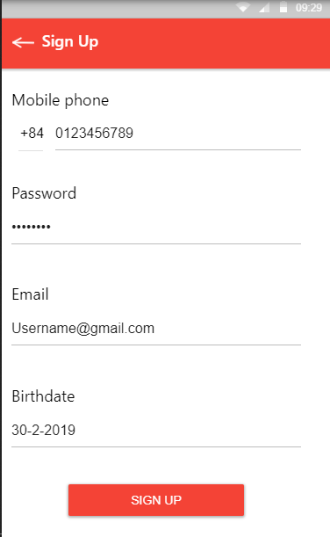Login
2. Register
3. 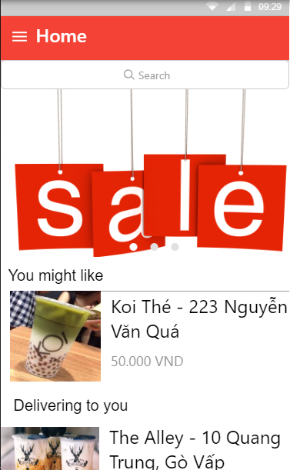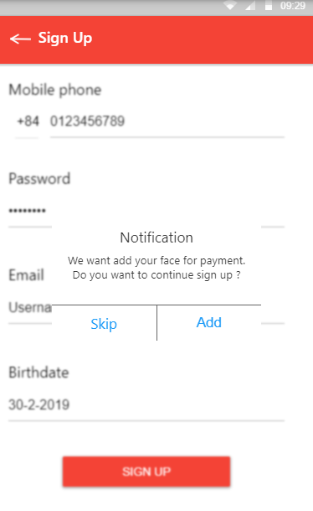Face Acceptation
4. Home
5. 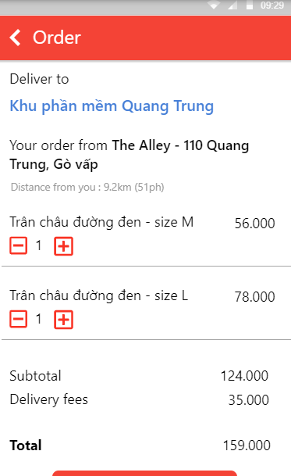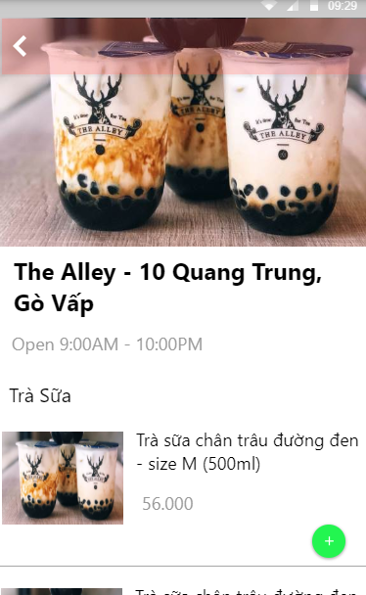Product/Store
6. Cart Order
7. 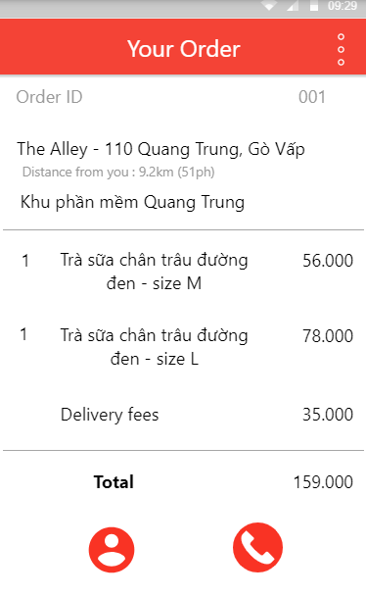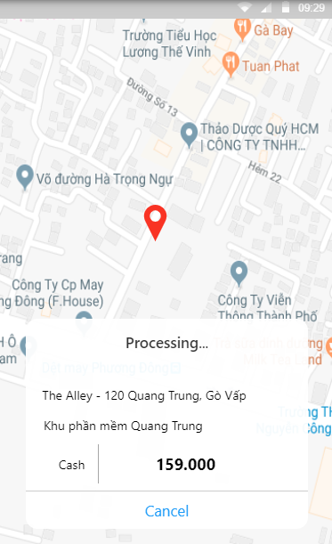Map/ Fee
8. Order Detail

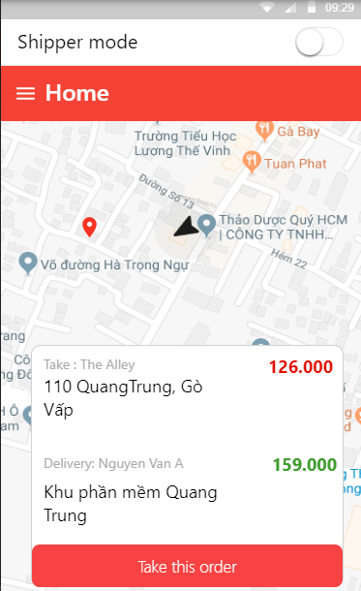

* **Shipper Mode**

1. 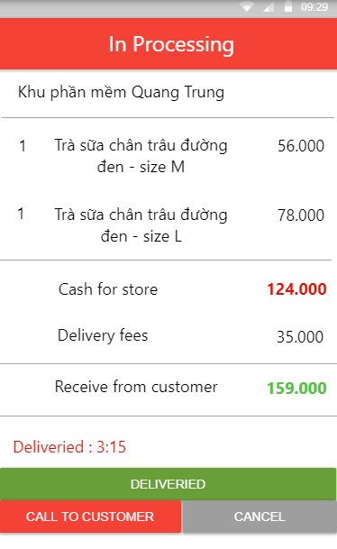Take Order
2. Order Detail
3. 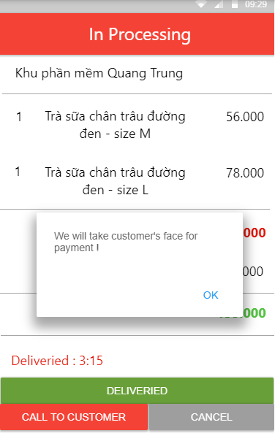Take Payment

## **5.2 Web Application**

1. 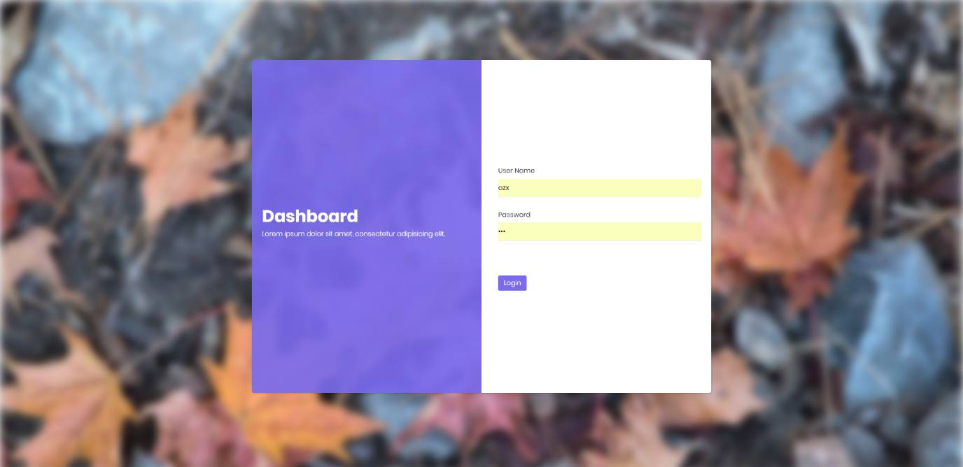Login
2. 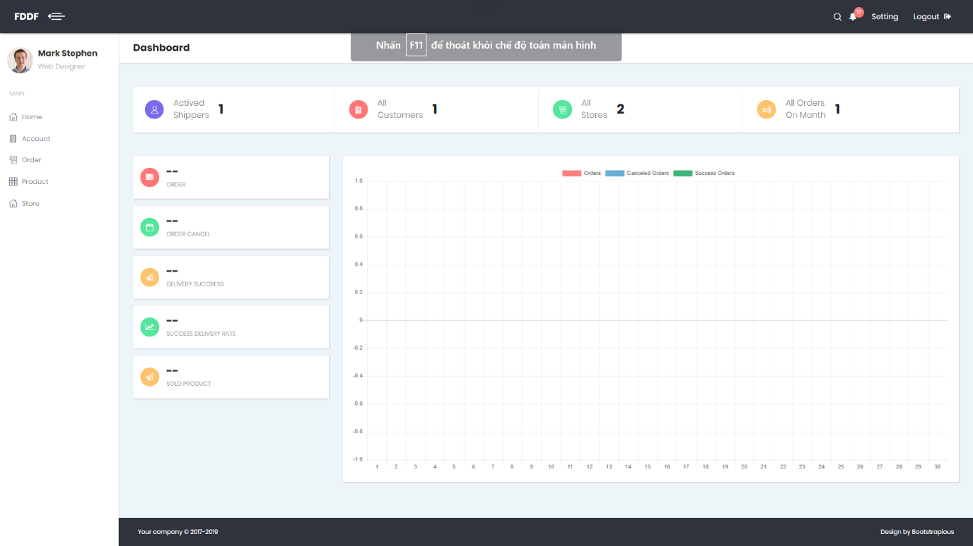Home and Statistic
3. 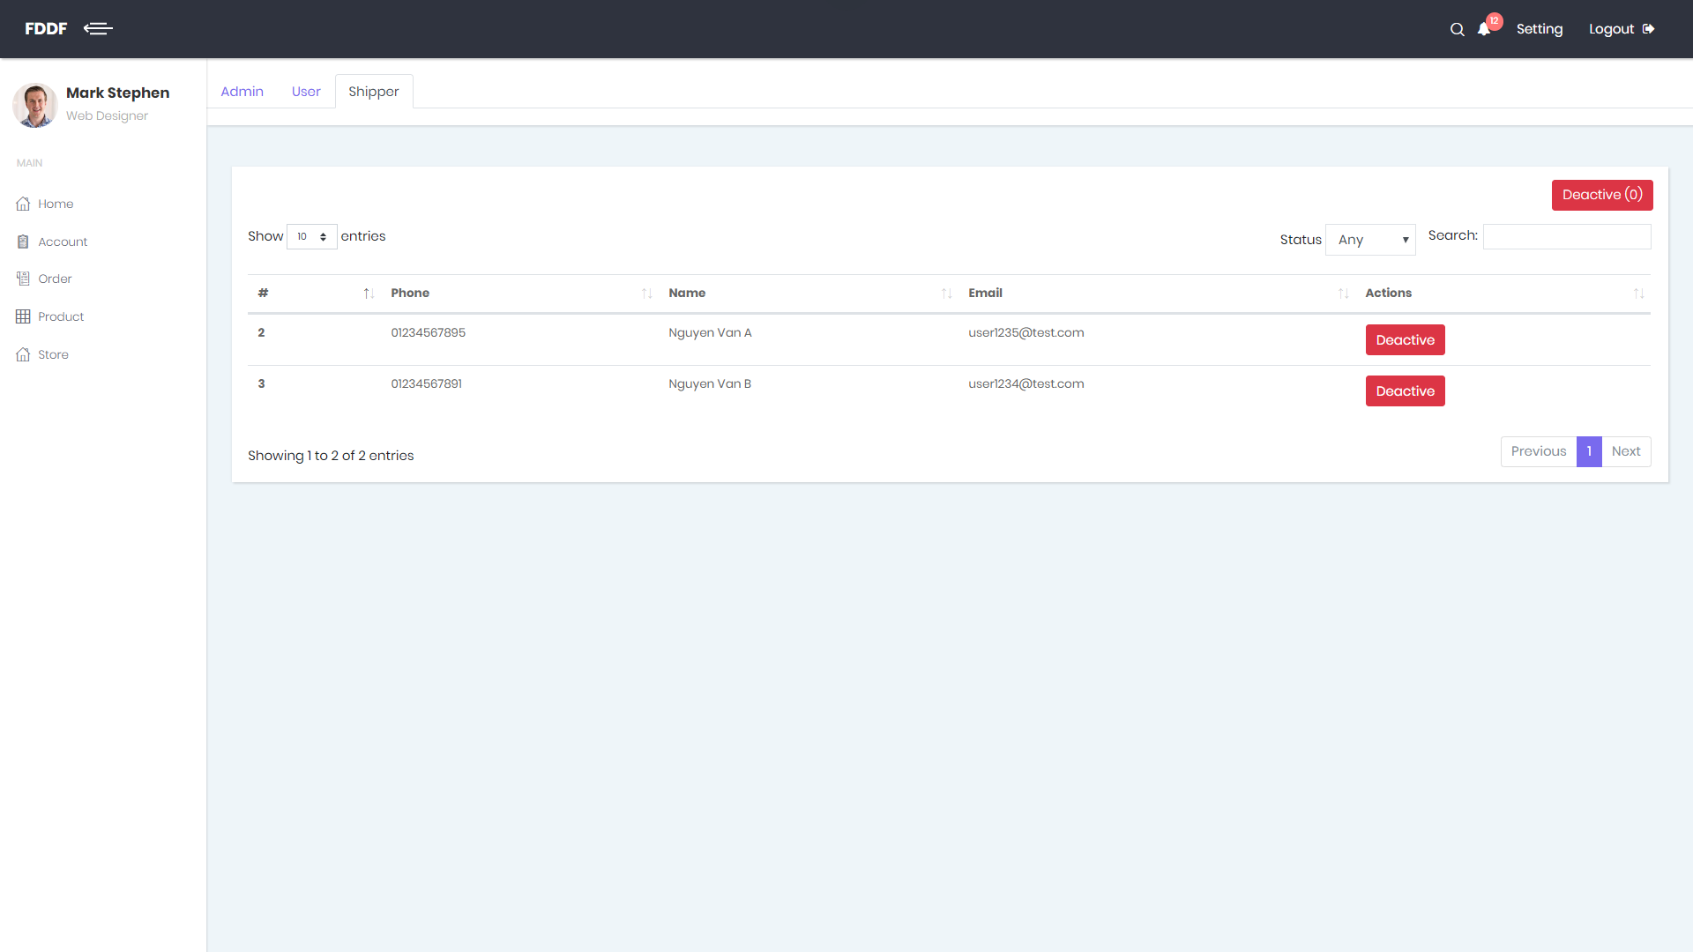Manage Account
4. 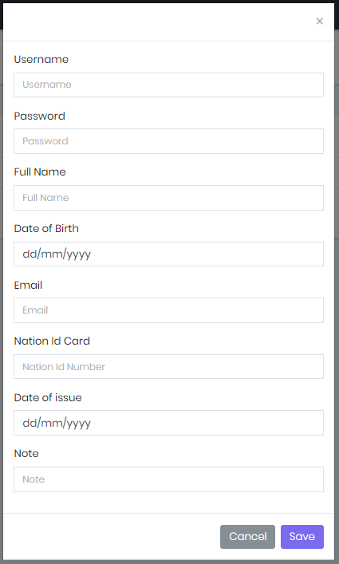Add -Detail Admin Modal
5. 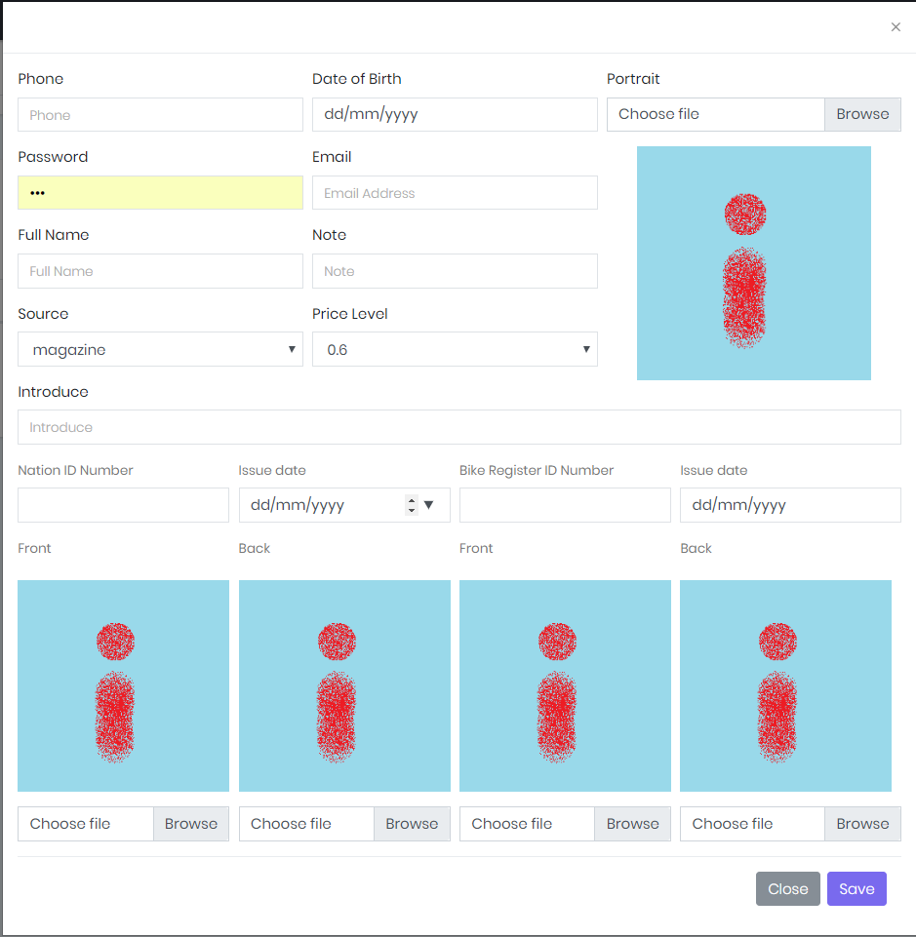Add -Detail Shipper Modal
6. 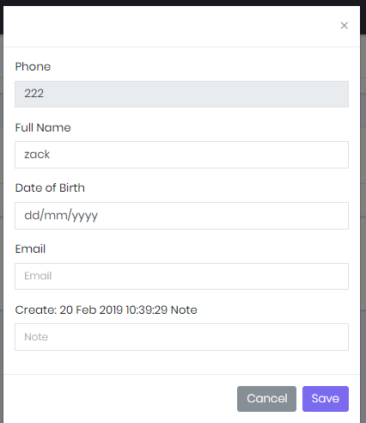Detail Customer Modal
7. 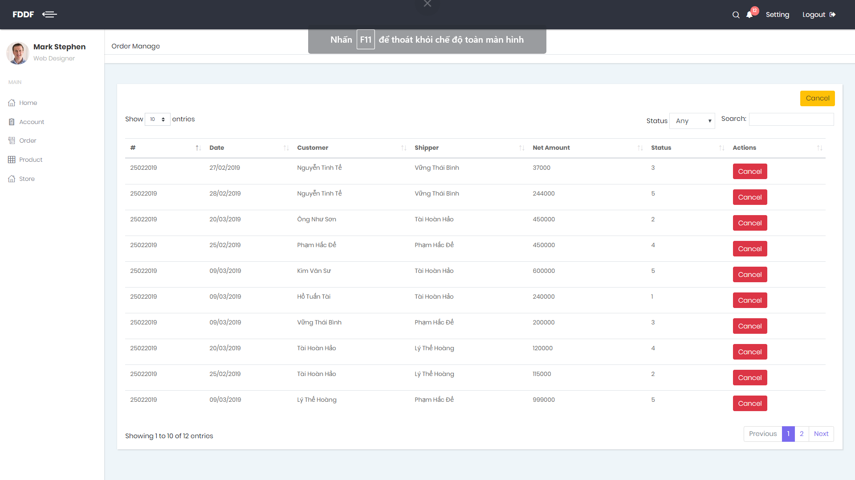Manage Order
8. 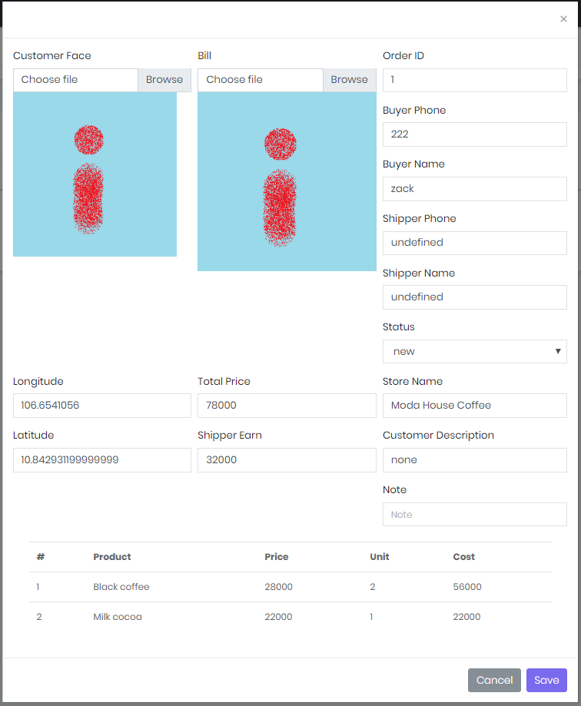Order Detail Modal
9. 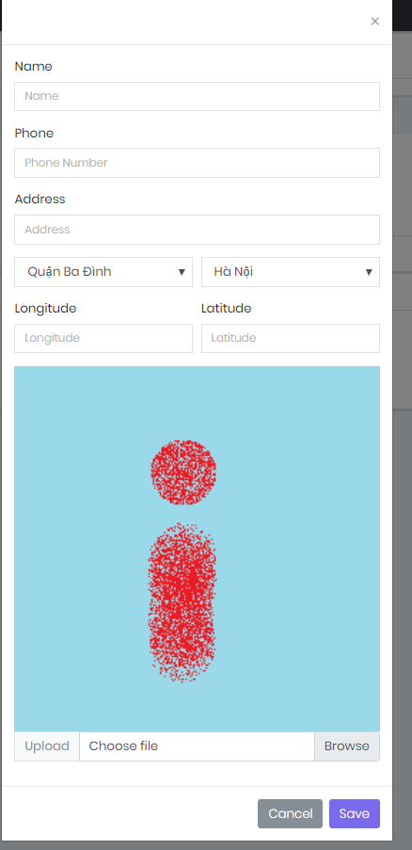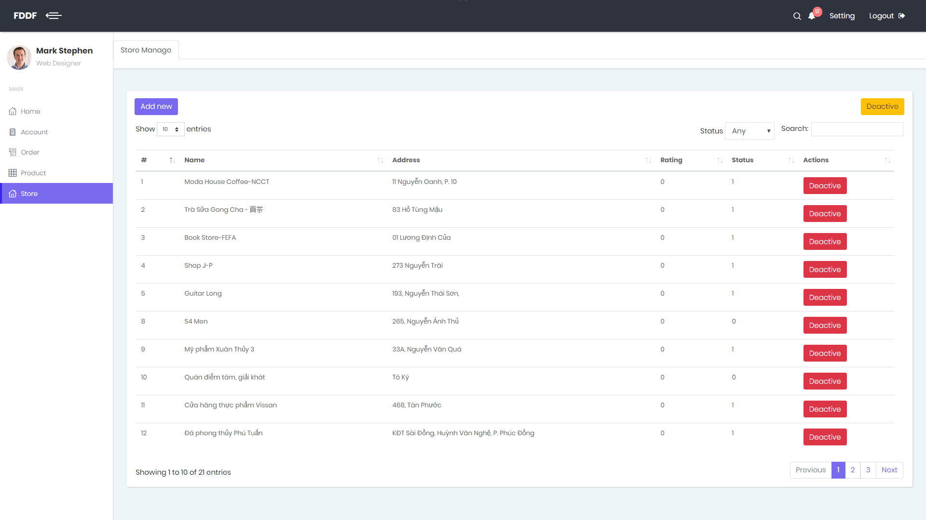Manage Store
10. Add New Store
11. 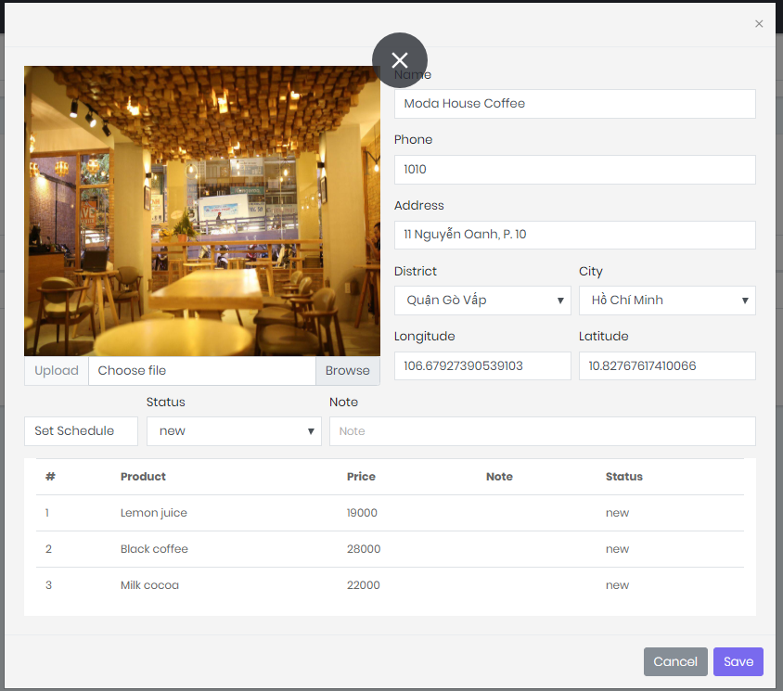Store Detail Popup
12. 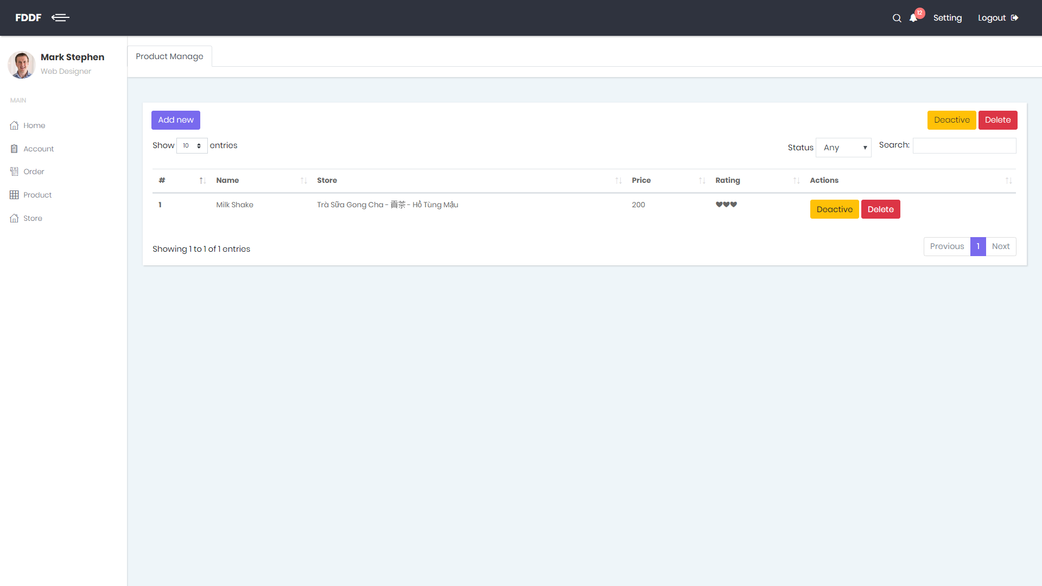Manage Product
13. 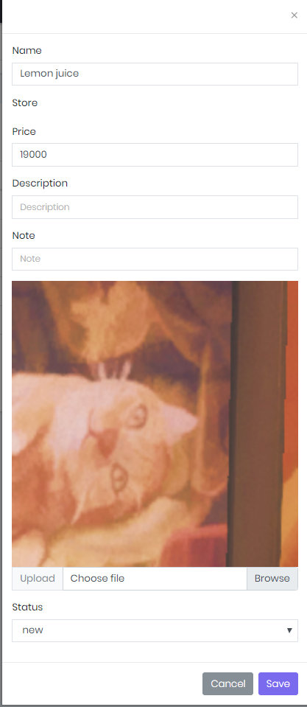Add-Detail Product Popup

# **6. Database Design**

## **6.1 Entity Relationship Diagram (ERD)**

Figure Entity Relation Diagram

## **6.2 Data Dictionary**

|  |  |  |
| --- | --- | --- |
| **Entity Data Dictionary: Describe content of all tables** | | |
| **No.** | **Table Name** | **Description** |
| 1 | Fr_account | Contain account information |
| 2 | Fr_city | Contain city information |
| 3 | Fr_district | Contain district data of city |
| 4 | Fr_order | Contain data of order’s list |
| 5 | Fr_order_detail | Contain data of order |
| 6 | Fr_payment_information | Contain data of payment |
| 7 | Fr_payment_type | Type of payment |
| 8 | Fr_price_level | Select price level for shipper |
| 9 | Fr_product | Contain data of every product of store |
| 10 | Fr_rating | Contain data rating of account for product and store |
| 11 | Fr_role | Contain data role of member |
| 12 | Fr_schedule | Contain open and close time of store |
| 13 | Fr_shipper | Contain data of shipper |
| 14 | Fr_source | Contain source of data |
| 15 | Fr_store | Contain data of store |
| 16 | Fr_weekday | Contian id for everyday (Monday, Tuesday, Sunday,…) |

Table Data Dictionary

# **7. Algorithms**